# Goal of pilot test

The goal of the pilot test is to obtain the coherence bandwidth from the PDP, and to ascertain the overall path loss assumptions.

# Safety procedures

* Use ESD wristbands when working with the PNA
* Double check connections before applying power
* Make sure the output is loaded before turning on power

# Equipment list

* PNA 5227A
* 2 x 4 GHz Directional antennas
* 1 x 4 GHz Omnidirectional antenna
* 1 x 5m cable (from PNA to Rx antennas)
* 1 x 12m (from PNA to Tx antennas)
* 1 x lossless splitter
* 2 x < 1m cables
* Calibration kit for through line calibration
* ESD wristbands

# Setup parameters

## PNA settings

* Change to time measurement
* Frequency: 4 GHz
* resBW: 200 MHz (5 ns resolution)
* ouput power: 15 dBm
* sampling frequency: 60 Hz
* sweep time: 10 s

# Setup

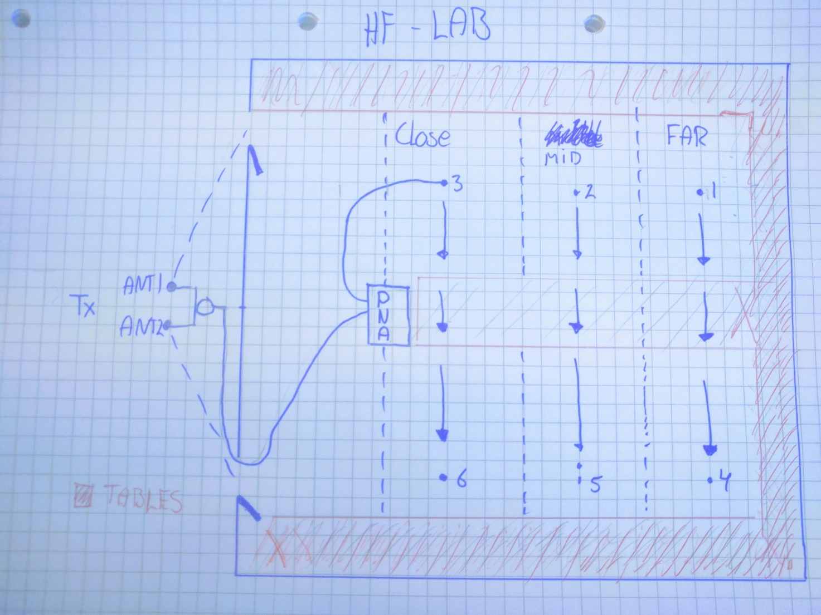

Connections (take picture)

# Procedure for pilot test

* Input setup from table in PNA
* Do a through line calibration with cables
* Connect antennas to PNA to obtain setup from figure
* Place Tx antennas at Tx position pointing towards the doors
* Hold Rx antenna at position 1 as seen on figure
* Start measurement while moving Rx antenna across the room to position 4
* Save measurement as “Far region”
* Reset now with Rx antenna at position 2 as seen on figure
* Start measurement while moving Rx antenna across the room to position 5
* Save measurement as “Mid region”
* Reset now with Rx antenna at position 3 as seen on figure
* Start measurement while moving Rx antenna across the room position 6
* Save measurement as “Close region”

# Goal of measurements

The goal of the measurements is to determine the distribution of fading gain in an office environment.

# Safety procedures

* Use ESD wristbands when working with the PNA
* Double check connections before applying power
* Make sure the output is loaded before turning on power

# Equipment list

* PNA 5227A
* 2 x 4 GHz Directional antennas
* 3 x 4 GHz Omnidirectional antenna
* 3 x 5m cable (from PNA to Rx antennas)
* 1 x 12m (from PNA to Tx antennas)
* 1 x lossless splitter
* 2 x < 1m cables
* Calibration kit for through line calibration
* ESD wristbands

# Setup parameters

## PNA settings

* Center frequency: 4 GHz
* Span: TBD (waiting pilot test)
* Number of points: TBD (dependent on span and resBW but less than 200)
* resBW: 40 Hz (dependent on PA and path loss)
* ouput power: 15 dBm

# Setup



Connections (take picture)

# Procedure for pilot test

* Input setup from table in PNA
* Do a through line calibration with cables
* Connect antennas to PNA to obtain setup from figure
* Place Tx antenna at Tx position pointing towards the doors
* Hold Rx antenna at back corner
* Start moving at TBD(speed) along the back wall and start measuring. (from position 1 to position 4)
* Move 3-5 cm out and move back towards position 1
* Repeat moving back and forth until the required amount of samples is collected (50-100 times)
* Save as “fading gain”